Experiment Details

|  |  |
| --- | --- |
| Department Name | Environmental |
| Class | T.Y.BTech |
| Semester | 5th |
| Subject Name | Water treatment laboratory |
| Experiment No. | 01 |
| Experiment Name | aeriation |

Version History

|  |  |  |  |  |
| --- | --- | --- | --- | --- |
| Sr. No. | Version Number | Created By | Approved By | Date |
| 1 | v1.0 | Abhishek Karmarkar | Faculty Name | 07/10/2001 |
|  |  |  |  |  |

AIM:

To determine the Rate of Aeration.

THEORY:

Aeration is necessary to promote the exchange of gases between the water and atmosphere. In water treatment aeration is practiced for following purposes.

* To add oxygen to water for imparting freshness e.g. water from underground sources devoid of or deficient in oxygen.
* Expulsion of carbon dioxide, hydrogen sulphide and other volatile substances causing taste and odour e.g. water from deeper layers of an impounding reservoir.
* To precipitate impurities like iron and manganese in certain forms e.g. water from some underground sources.

APPARATUS-: diffused aerator, burrete , pippete , 300ml DO bottle , conical flask , measuring cylinder , glass jar

CHEMICALS: alkali iodide azide solution (KOH+KI) , MnsO4 (manganese sulphate ) , Conc. H2 SO4 , starch ,

indicator , sodium thiosulphate(0.025 N) , sodium sulphite

PRE TEST:

1. The D.O. is expressed in terms of?
2. g/lit
3. **mg/ lit**
4. kg/ lit
5. lit/ lit
6. more the D.O better the quality of water
7. **yes**
8. no
9. cant say
10. maybe
11. the D.O. is important for human health?
12. No
13. **Yes**
14. Maybe
15. None of the above
16. Does temperature affects the D.O. level ?
17. **Yes**
18. No
19. Maybe
20. Never
21. Aeriation is important for the safe drinking of water ?
22. **Yes**
23. No
24. Maybe
25. Never

PROCEDURE:

1. Take 300 ml of water in DO bottle.
2. Add 2 ml of manganese sulphate just below the liquid surface.
3. Add 2 ml of alkali iodide azide to the solution.
4. Presence of oxygen will form the brownish orange precipitate or floc.
5. Allow it to settle for sufficient time in order to react with oxygen completely.
6. Add 2 ml of concentrated H2 SO4 through pipette at the surface of the water.
7. Carefully fix the stopper and invert the bottle to dissolve the floc.
8. Rinse the burette with sodium thiosulphate and fill it again with sodium thiosulphate and fix the burette to the stand.
9. Measure 203 ml of water from DO bottle and transfer it to the conical flask.
10. Titration should start immediately after the transfer of the water.
11. Add 3-4 drops of starch indicator and titrate against sodium thiosulphate.
12. End point of titration is blue colour to coloureless.
13. Note dowm the sodium thiosulphate added which gives the DO concentration.
14. Take down the DO level of a given sample and plot conc. Against time.

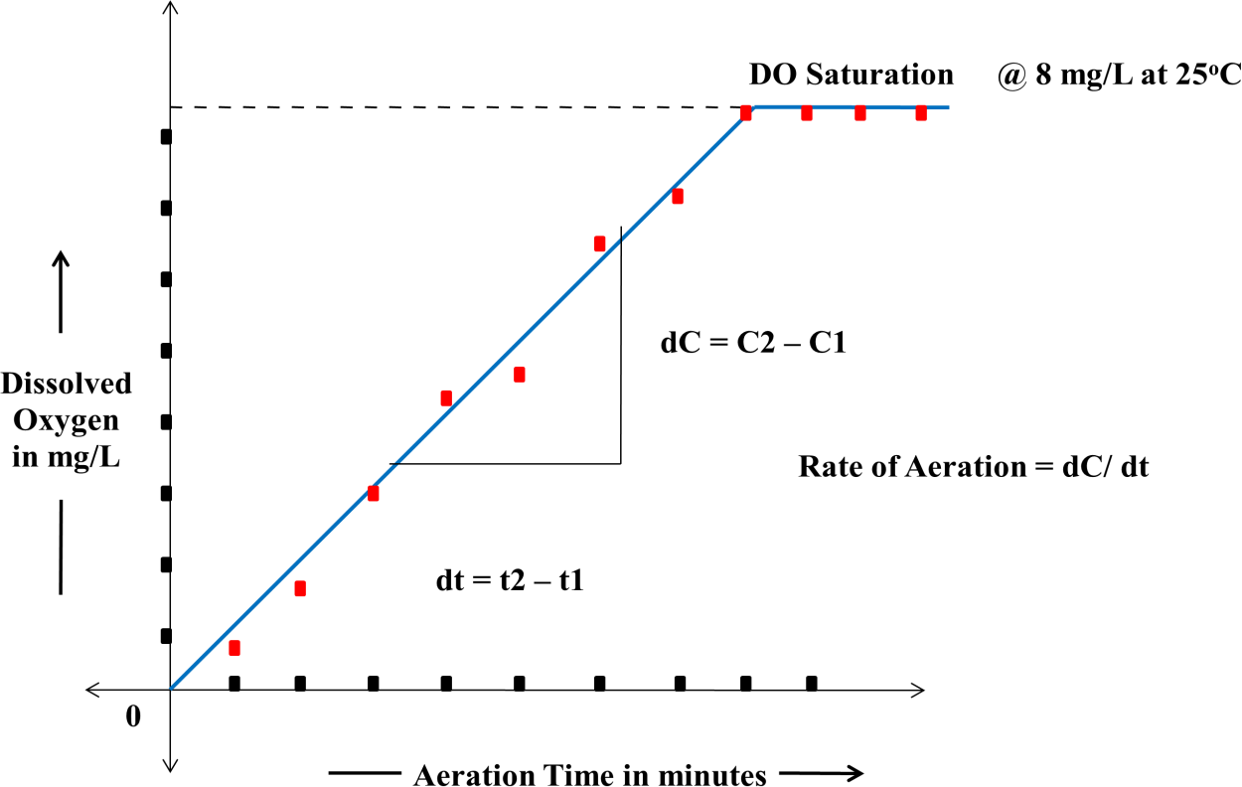

**DO ( $\frac{mg}{}L)$ = $(ml of titrant required ×normality of titrant ×1000 ×8)$/ ml of sample**

POST TEST:

1. What is the normality of sodium thiosulphate taken ?
2. 0.05
3. 0.35
4. **0.025**
5. 0.04
6. The absence of brownish precipitate indicates ?
7. **Absence of oxygen**
8. Lack of oxygen
9. Oxygen in abundant amount
10. None
11. The DO with indication zero represents ?
12. Water is pure
13. Oxygen is abundant
14. **Not suitable for drinking**
15. None
16. As the time increases DO should ?
17. Decrease
18. Remain same
19. Can’t say
20. **Increase**
21. The graph between time and DO level gives ?
22. Curve
23. **Straight line**
24. Parabola
25. Depends

REFERENCES:

KIT Environmental engineering department T.Y. BTech